**BigQuery Implementation**

**Problem Definition**: Find out the most popular genre of the current book collection through the records people borrowed.

1. Create table and read .csv file which is record file, inventory, and dictionary
2. **Record file.csv**

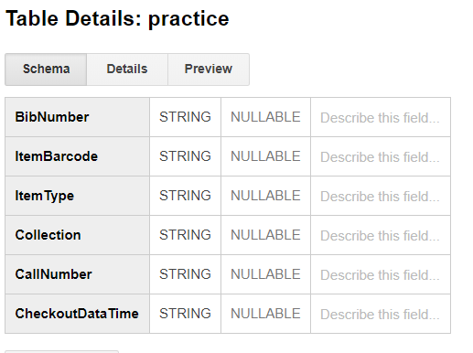

1. **Inventory.csv**

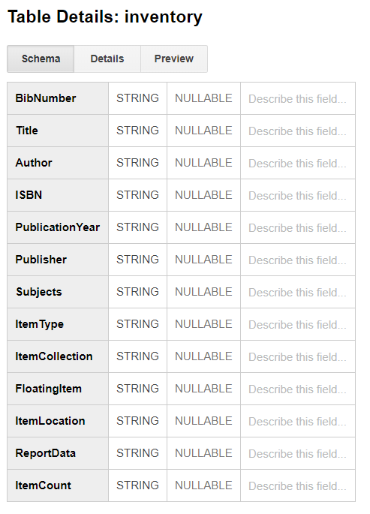

1. **Dictionary.csv**

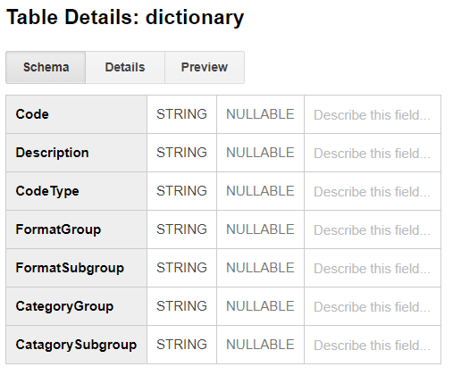

1. **Query**

First, we linked the BibNumber attribute of the practice with the BibNumber attribute of the inventory, and the ItemType attribute of the practice, and the Code attribute of the dictionary to join the three tables. Then, Group by the ItemType and Descriptrion for finding the ItemType people borrowed the most. Finally, we show the description of the most popular order of genres.

1. Query

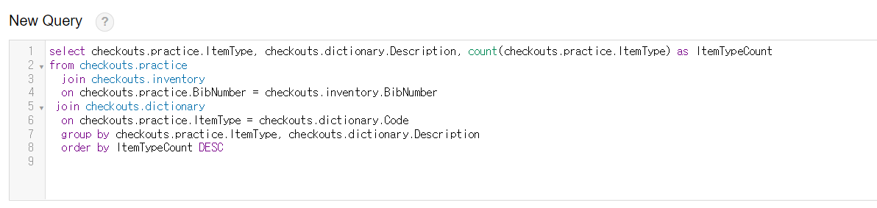

1. Result

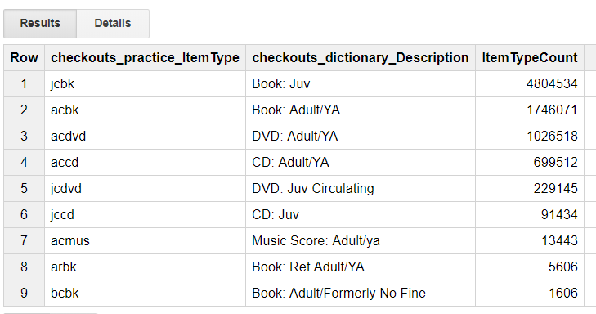

1. **Limitation: failure merging the .csv files**

We tried to merge data in each csv file into one csv file, but the limit of rows supported by Excel was 1048576, so we could not even load all of our data sets. Also, we tried to join the data by joining but it took 926 seconds to join only the two data sets, which was impossible to load the data.

1. excel

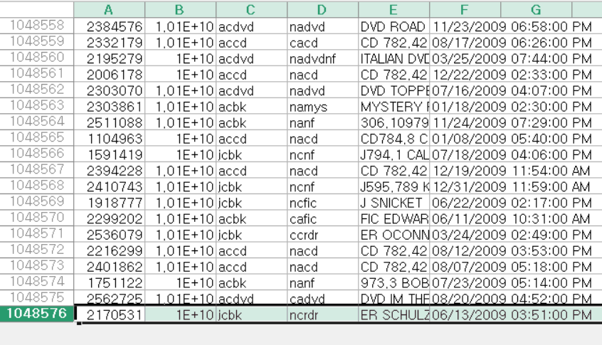

1. join query

